**Containerize The App**

|  |  |
| --- | --- |
| **Date** | 08 November 2022 |
| **Team ID** | PNT2022TMID17944 |
| **Project Name** | Smart Fashion Recommender Application |

**DOCKER PUSH:**

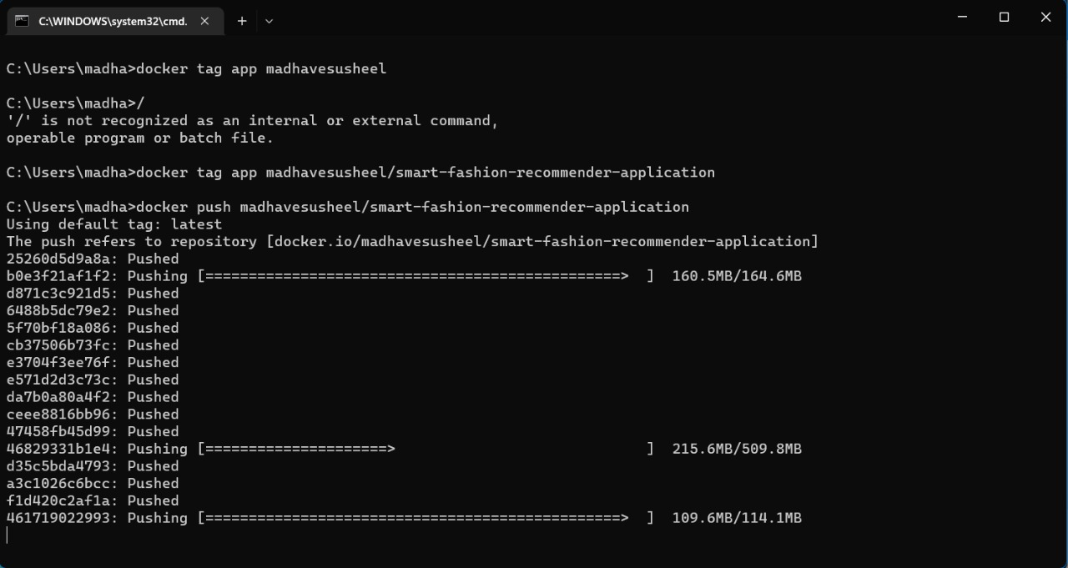

**CONTAINERIZING THE APPLICATION:**

